8085 Pin Configuration
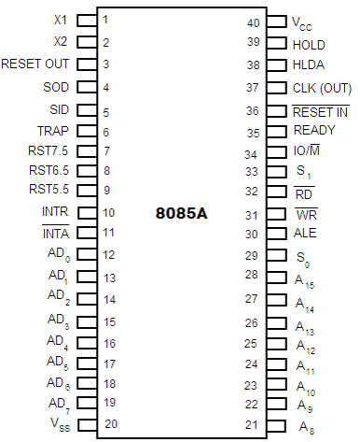
The descriptions of various pins are as follows:
Address Bus and Data Bus
A₈ -A₁₅ (Output):
These are address bus and are used for the most significant bits of the memory address or 8-bits of I/O address.
AD₀ -AD₇ (Input/output):
These are time multiplexed address/data bus i.e. they serve dual purpose. They are used for the least significant 8 bits of the memory address or I/O address during the first cycle. Again they are used for data during 2nd and 3rd clock cycles.

Control and Status Signals
ALE (Output):
ALE stands for Address Latch Enable signal. ALE goes high during first clock cycle of a machine cycle and enables the lower 8-bits of the address to be latched either into the memory or external latch.
IO/M (Output):
It is a status signal which distinguishes whether the address is for memory or I/O device.
S₀, S₁ (Output):
These are status signals sent by the microprocessors to distinguish the various types of operation given in table below:

Status codes for Intel 8085
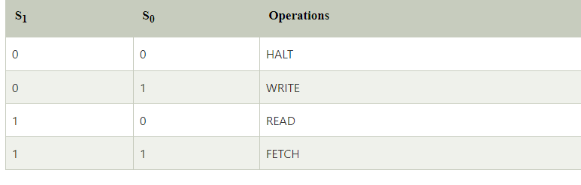
RD (Output):
RD is a signal to control READ operation. When it goes low, the selected I/O device or memory is read.
WR (Output):
WR is a signal to control WRITE operation. When it goes low, the data bus' data is written into the selected memory or I/O location.
READY (Input):
It is used by the microprocessor to sense whether a peripheral is ready to transfer a data or not. If READY is high, the peripheral is ready. If it is low the micro processor waits till it goes high.

Interrupts and Externally Initiated Signals
HOLD (INPUT): HOLD indicates that another device is requesting for the use of the address and data bus.
HLDA (OUTPUT): HLDA is a signal for HOLD acknowledgement which indicates that the HOLD request has been received. After the removal of this request the HLDA goes low.
INTR (Input): INTR is an Interrupt Request Signal. Among interrupts it has the lowest priority. The INTR is enabled or disabled by software.
INTA (Output): INTA is an interrupt acknowledgement sent by the microprocessor after INTR is received.
RST 5.5, 6.5, 7.5 and TRAP (Inputs): These all are interrupts. When any interrupt is recognized the next instruction is executed from a fixed location in the memory as given below:
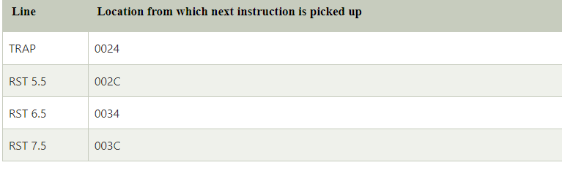
Reset Signals
RESET IN (Input):
It resets the program counter (PC) to 0. It also resets interrupt enable and HLDA flip-flops. The CPU is held in reset condition till RESET is not applied.
RESET OUT (Output):
RESET OUT indicates that the CPU is being reset.
Clock Signals
X1, X2 (Input): X1 and X2 are terminals to be connected to an external crystal oscillator which drives an internal circuitry of the microprocessor. It is used to produce a suitable clock for the operation of microprocessor.
CLK (Output): CLK is a clock output for user, which can be used for other digital ICs. Its frequency is same at which processor operates.
Serial I/O Signals
SID (Input): SID is data line for serial input. The data on this line is loaded into the seventh bit of the accumulator when RIM instruction is executed.
SOD (Output): SOD is a data line for serial output. The seventh bit of the accumulator is output on SOD line when SIM instruction is executed.
Power Supply
Vcc : +5 Vlots supply
Vss : ground reference

